**Smart Lock**

**Goal of the App:**

Smart Lock enhances your phone protection a step further by letting you know about the intruder or when untrusted people with you are trying to access your phone illegitimately when you are not around.

* It gives you a word of caution by sending you an email alert with the image of the person trying to access your phone after 3 unsuccessful attempts of password entry.
* If no internet access is available, you will receive a notification redirecting to the location the image file is stored on the phone.

**High-level architecture:**

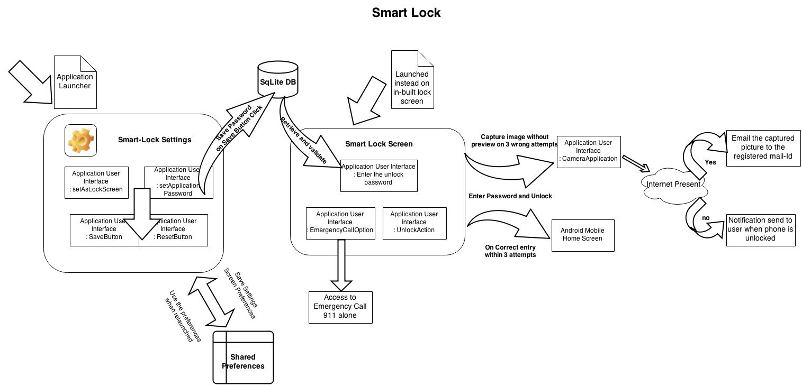

**Android techniques:**

The application has,

**Three activities:** Application Settings, Application Lock Screen and Custom Camera without preview.

**One Service:** To monitor the activity (Application Lock Screen) and to relaunch it when it goes to the background on the event of various navigations in the unlock mode.

**One Receiver:** This extends the Broadcast Receiver and listens to actions related to android device boot; lock (Screen on / off)

**SQLite Database:** This database is used to store the passwords saved in the Settings Screen of the application.

**Shared Preferences:** It is used throughout the program to maintain the state of any activity when stopped / closed.

**Example Scenario:**

The Settings screen has a toggle switch which can be used by the user to decide whether he needs to activate this application lock or not.

This is to provide an additional flexibility of temporarily disabling the app rather than uninstalling it.

This option of user is stored in the preferences and displayed back to the user whenever he visits the Settings screen again.

**Notification:** The owner of the phone is notified about the new photo capture of the person who tried to unlock the phone, yet unsuccessful on 3 consecutive attempts. The notification when clicked redirects the user to the destined folder/ image

**Mail:** When internet is available the photo is directly mailed to the registered email address of the owner and deleted from the phone’s storage.

**Concepts used while implementation:**

1. **Overriding the home button for the lock application :**

From Android 4.0 and above home button cannot be overridden. So for handling this situation indirectly, with the accepted latency observed concepts of Alarm Manager and Activity Manager were used.

* **Alarm Manager** was used to trigger alarm whenever the Lock application without a successful unlock attempt, is pushed to background by the home application.
* When the alarm is triggered, the older instance of the lock application if still present/ the new instance is started and brought back to foreground.
* **Activity Manager** monitors and provides the current foreground activity.

1. **Allowing Incoming Phone calls** to override the lock screen and relaunch it back when the call ends

* Telephony Manager was used to observe **CallStateChange ()**.
* Based on the returned state and the current screen class **IsCallScreen**, the application is proceeded.

1. **Camera without preview surface:** It is highly necessary to capture the photo of the person without their notice. So a surface view which acts as a dummy preview was used to achieve this
2. **Overriding the in-built application Lock Screen:** The broadcast receiver was used to handle the intents actions like **ACTION_SCREEN_OFF, ACTION_SCREEN_ON, and ACTION_BOOT_COMPLETED** to capture the situations which are required to launch the new Smart Lock Screen.

**Testing Snapshots:**

**Tested on Device: Samsung Galaxy S4**

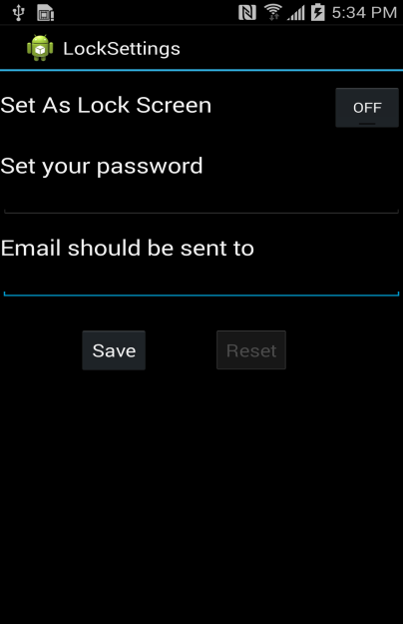 The screen has a toggle button which indicates the activation/deactivation of application.

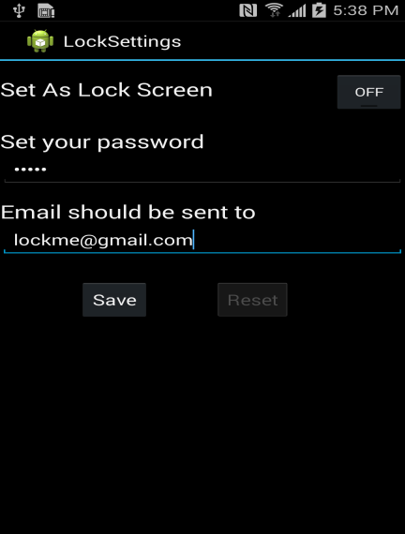 On click on save, stores all the credentials in the SQLite database

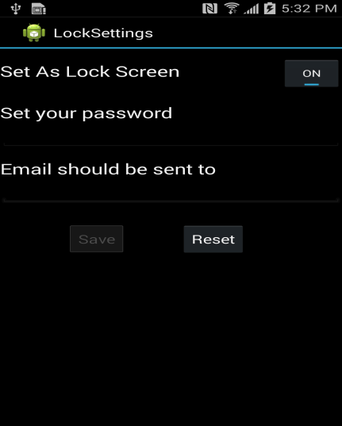 When application is active and passwords are already set, only the reset option is available for use.

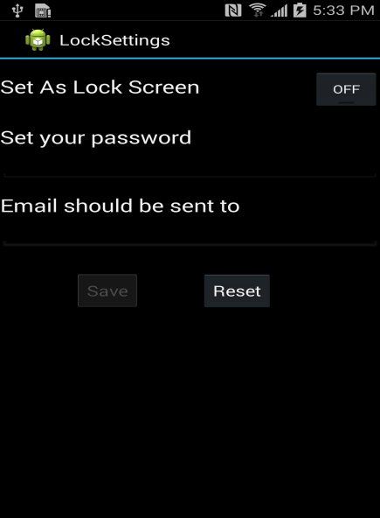

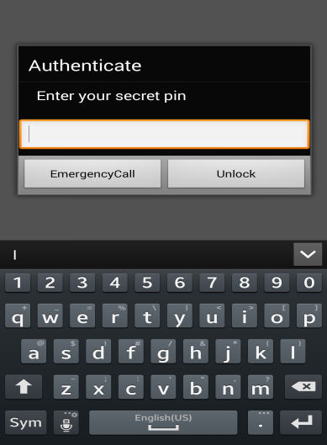Application Lock Screen with the Unlock and Emergency Call Option.

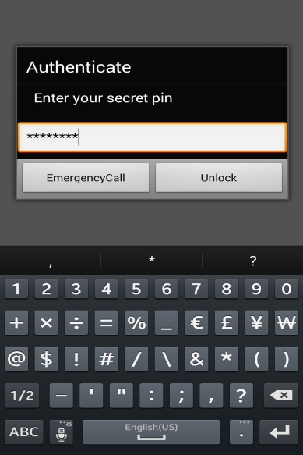

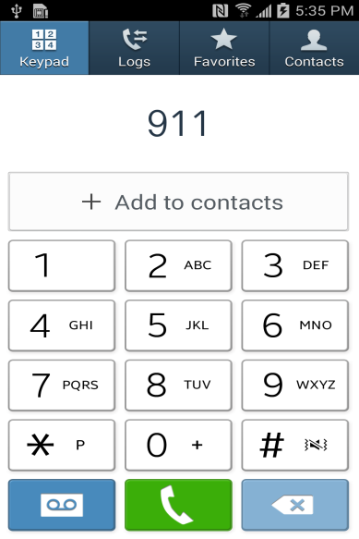

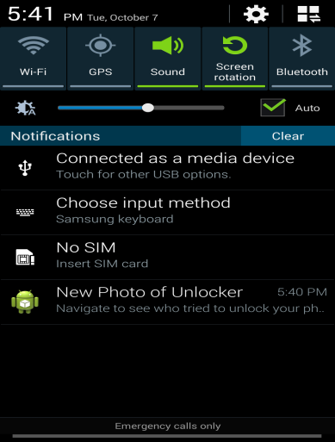

Notifications sent when no internet connection is available. It redirects to the local storage location.

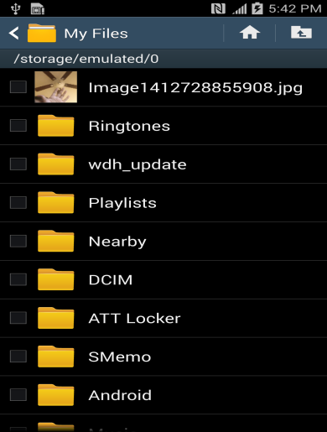

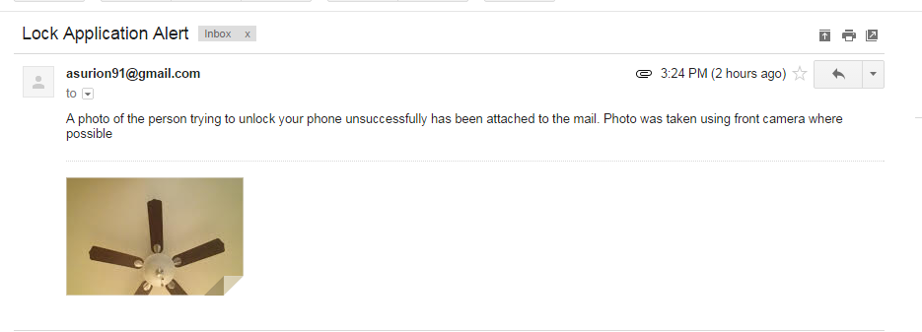

**Future Enhancements:**

* Location based notifications
* Customizing the no of attempts
* Lock interface to include pattern based unlock
* As a Standalone lock app which can used on top of any other application.
* Transitional delay to reduced and reduce the response time further.